**Problem 1: Read the instructions carefully and answer accordingly. If there is any need to insert some data then do that as well.**

1. **Navigate and List:**

a. Start by navigating to your home directory and list its contents. Then, move into a directory named "LinuxAssignment" if it exists; otherwise, create it.

Output

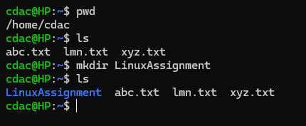

pwd : – Present working Directory

ls :- It list out all the files and directory of current working directory.

mkdir :- It is used to create new directory.

**b.** **File Management:**

a. Inside the "LinuxAssignment" directory, create a new file named "file1.txt". Display its contents.

Output

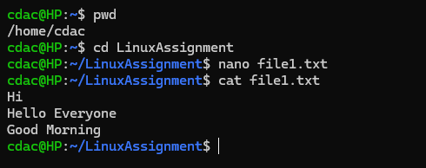

Cd :- This command used to change directory

Nano :- It is actually run the editor and open the specified file.

Cat :-To display content of the file on console.

1. **Directory Management:**

a. Create a new directory named "docs" inside the "LinuxAssignment" directory.

Output

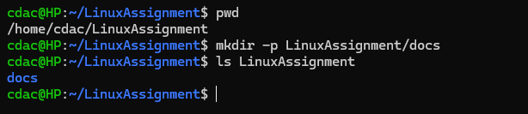

P :- this commond is used to create parent directory

ls :- listout the directory

**d. Copy and Move Files:**

a. Copy the "file1.txt" file into the "docs" directory and rename it to "file2.txt".

Output

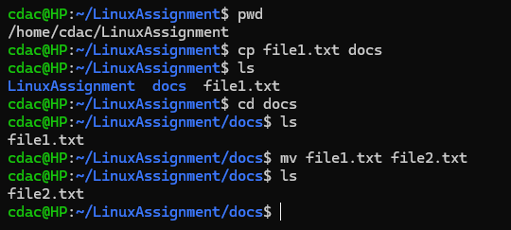

cp :- It is used to copy files and directories from one location to another.

Mv :- This command is used to move files and directories from one directory to another or to

rename a file or directory

**e. Permissions and Ownership:**

a. Change the permissions of "file2.txt" to allow read, write, and execute permissions for the

owner and only read permissions for others. Then, change the owner of "file2.txt" to the current

user.

Output

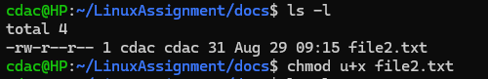

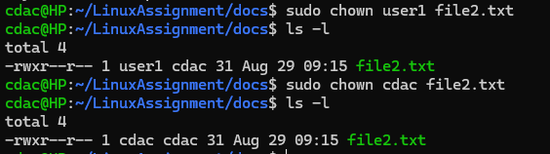

Sudo :- To give some Specific privilages to the user’s other than root

Chown :-This command is used to change the file owner or Group.

**F. Final Checklist:**

a. Finally, list the contents of the "LinuxAssignment" directory and the root directory to ensure

that all operations were performed correctly.

Output

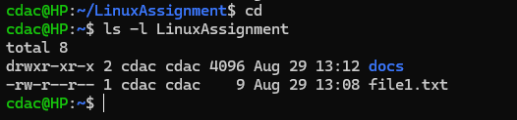

ls –l :- This command is use to list information about files and directories

**g. File Searching:**

a. Search for all files with the extension ".txt" in the current directory and its subdirectories.

Output

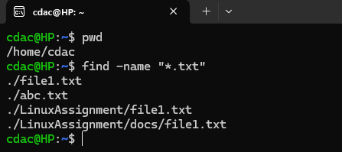

b. Display lines containing a specific word in a file (provide a file name and the specific word to

search).

Output

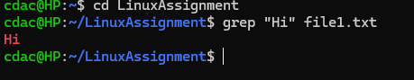

find :- This command is used to find files and directories and perform operations on them.

Grep :- By using this command we display specific word in a file.

**h. System Information:**

a. Display the current system date and time.

Output



date : Using this command we display current date and time.

**I. Networking:**

a. Display the IP address of the system

output

.

b. Ping a remote server to check connectivity (provide a remote server address to ping).

Output

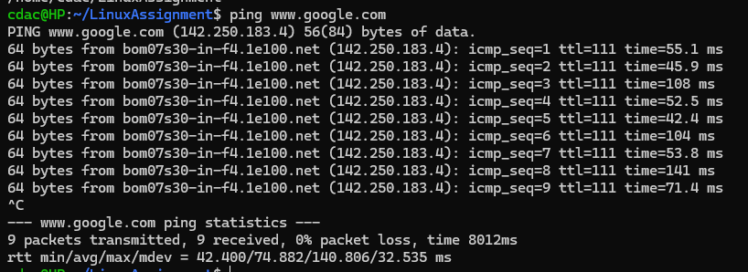

hostname -I :- Usiging this command display the IP address of the system

ping :- Using this command check server availability, monitoring network performance.

**J. File Compression:**

a. Compress the "docs" directory into a zip file.

Output

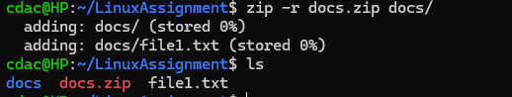

b. Extract the contents of the zip file into a new directory.

Output

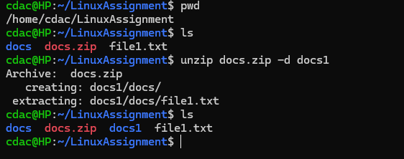

zip –r docs.zip docs/ :- This command is used to zip docs directory

unzip docs.zip –d docs1 :- This command is used extract the content of the zip file into new

directory

**k. File Editing:**

a. Open the "file1.txt" file in a text editor and add some text to it.

Output

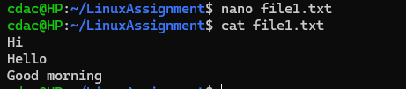

nano :-nano is a editor and open the specified file.

b. Replace a specific word in the "file1.txt" file with another word (provide the original word

and the word to replace it with).

Output

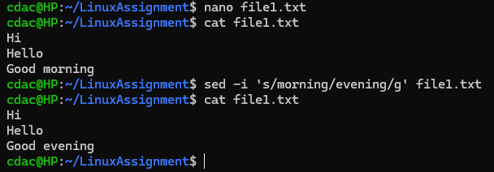

Sed –i :- This command is used to perform text transformation and manipulation on a file

**Problem 2: Read the instructions carefully and answer accordingly. If there is any need to insert some data then do that as well.**

**a.** Suppose you have a file named "data.txt" containing important information. Display the first 10 lines

of this file to quickly glance at its contents using a command.

Output

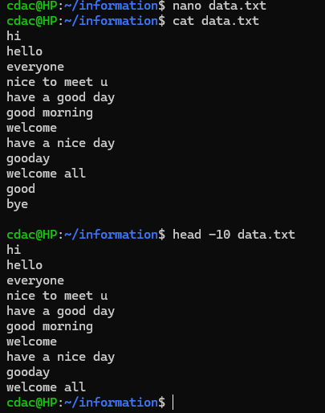

Create data.txt file using nano command

head :- This command display top lines of the file on console

1. Now, to check the end of the file for any recent additions, display the last 5 lines of "data.txt" using another command.

Output

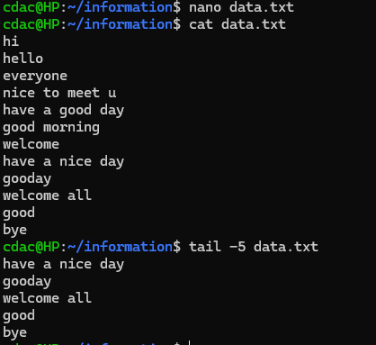

In this question create data.txt file first

tail – this command display bottom line of the file on console.

1. In a file named "numbers.txt," there are a series of numbers. Display the first 15 lines of this file to

analyze the initial data set.

Output

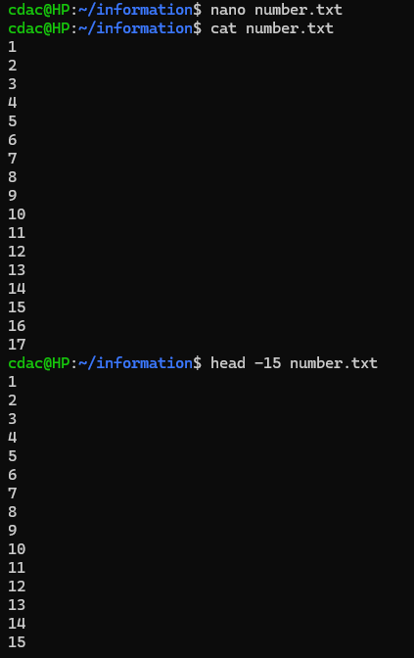

1. To focus on the last few numbers of the dataset, display the last 3 lines of "numbers.txt".

Output

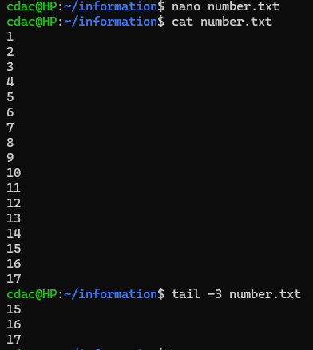

1. Imagine you have a file named "input.txt" with text content. Use a command to translate all

lowercase letters to uppercase in "input.txt" and save the modified text in a new file named "output.txt.”

Output

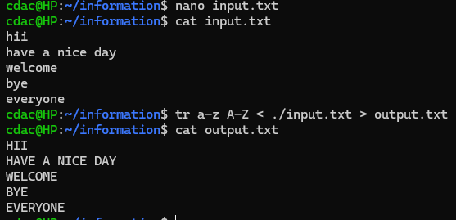

Create file input.txt with text content using nano command.

Display output using cat command

tr :- Use of this command to translate or delete character in lower and uppercase letter

redirection (>):- using this symbol save modified text in a new file

1. In a file named "duplicate.txt," there are several lines of text, some of which are duplicates. Use a command to display only the unique lines from "duplicate.txt."

output

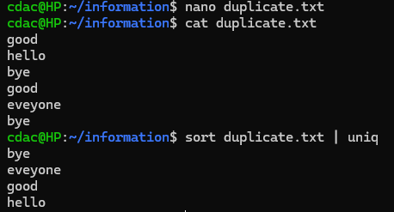

Create file duplicate.txt with text content using nano command.

Display output using cat command

sort :- using this command to print the output of a file in given order

pipe(|) :- to redirect the standard output of one command to the standard input of

another command.

uniq :- uniq command is used to remove all the repeated lines from a file.

1. In a file named "fruit.txt," there is a list of fruits, but some fruits are repeated. Use a command to

display each unique fruit along with the count of its occurrences in "fruit.txt."

Output

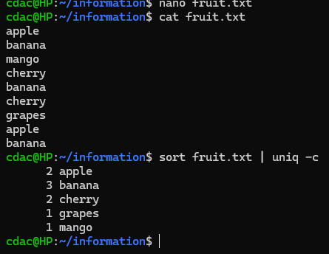

Create file fruit.txt with text content using nano command.

Display output using cat command

sort :- using this command to print the output of a file in given order

pipe(|) :- to redirect the standard output of one command to the standard input of

another command.

uniq -c :- Using this command we count occurrences